Lab 1 - Create Your First Agent
In this lab, you'll create your first agent with Microsoft Copilot Studio. The agent that you are going to create helps users to find information about HR policies and processes to
- hire or layoff employees,
- improve your career, and
- to define learning pathways.
In this lab you will learn:
- How to create an agent with Copilot Studio
- How to configure a custom icon for your agent
- How to configure knowledge sources for your agent
Disclaimer: UI may differ

Exercise 1 : Creating an agent with Copilot Studio

Step 1: Creating a new agent
To create a new agent, open a browser and, using the provided account, go to https://copilotstudio.microsoft.com to start using Microsoft Copilot Studio.
Select Create an agent command in the middle of the screen, like illustrated in the following screenshot.
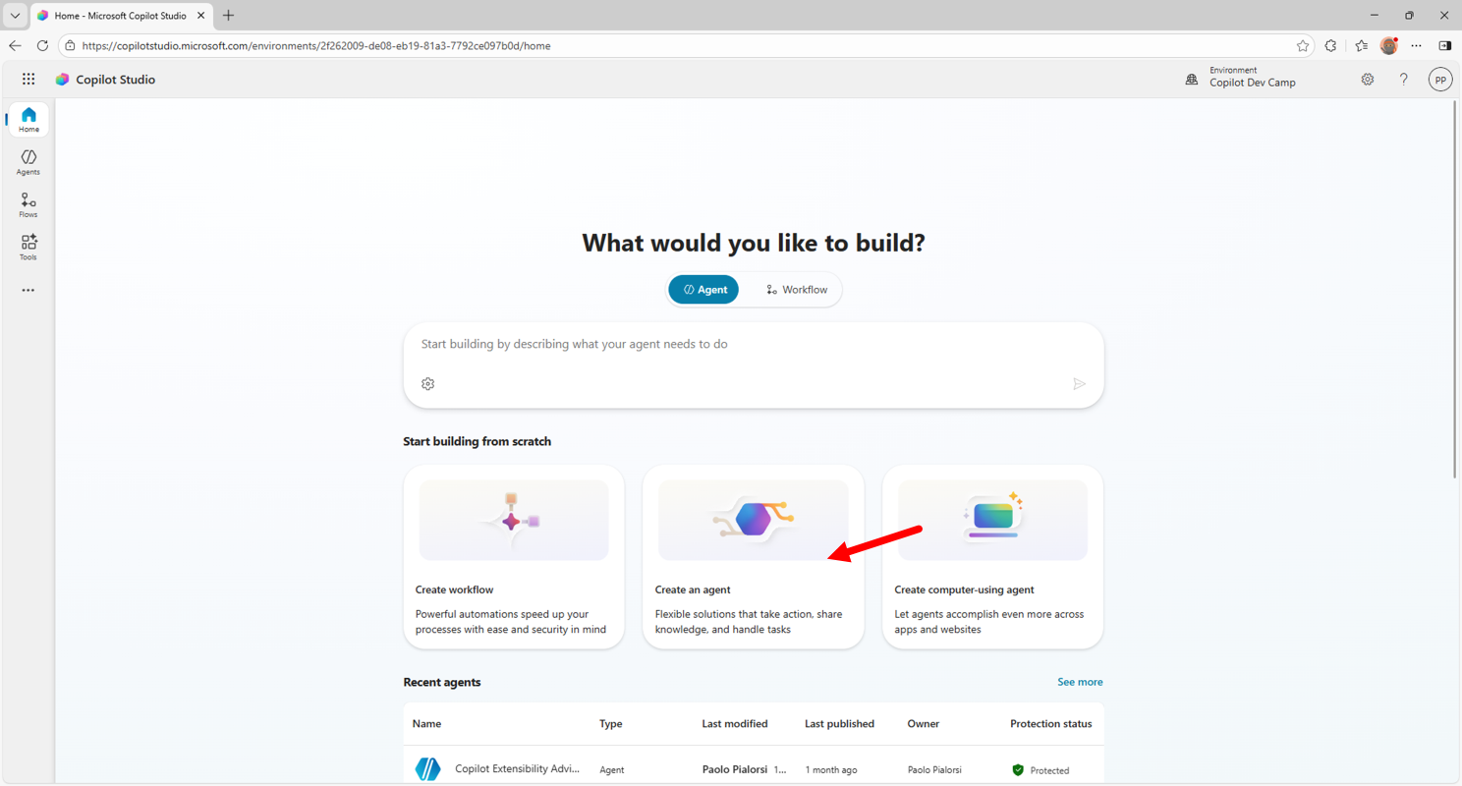
You can achieve the same result also selecting Agents on the left side of the screen and then selecting + Create blank agent in the upper right side of the screen.
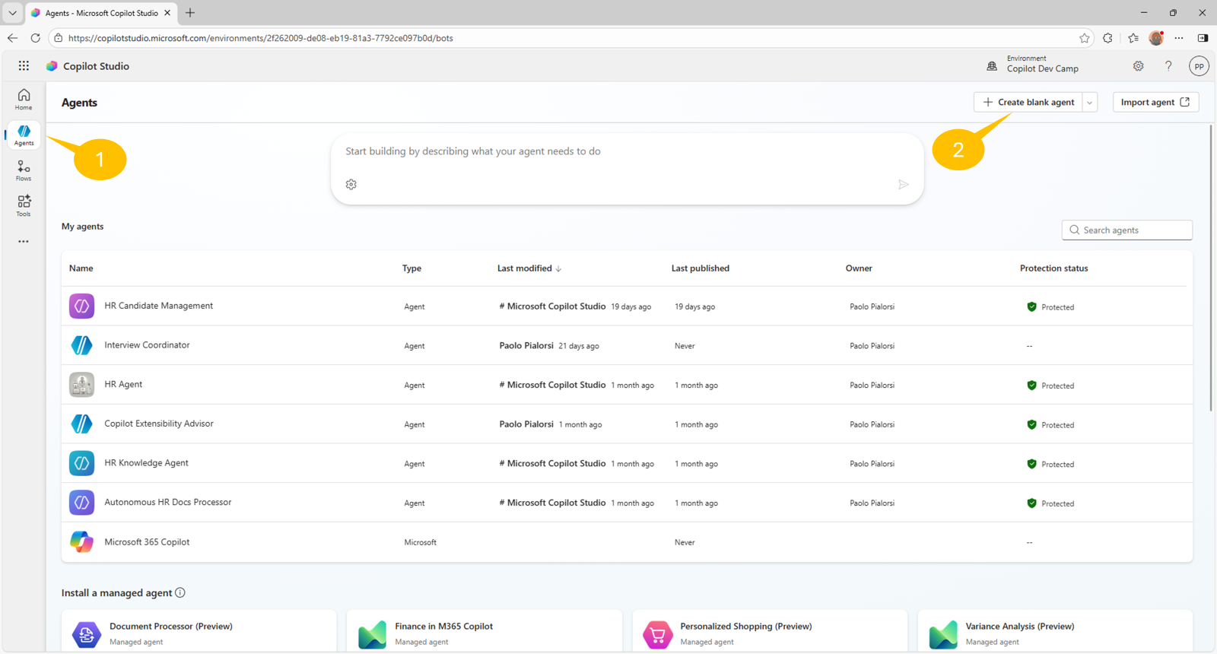
After waiting a little while, you will be redirected to the page from which you can configure a newly created agent. From here you can configure all the settings of your agent, like for example:
- Name
- Icon
- Description
- Model
- Triggers
- Instructions
- Knowledge
- Web Search
- Tools
- Agents
- Topics
- Suggested prompts
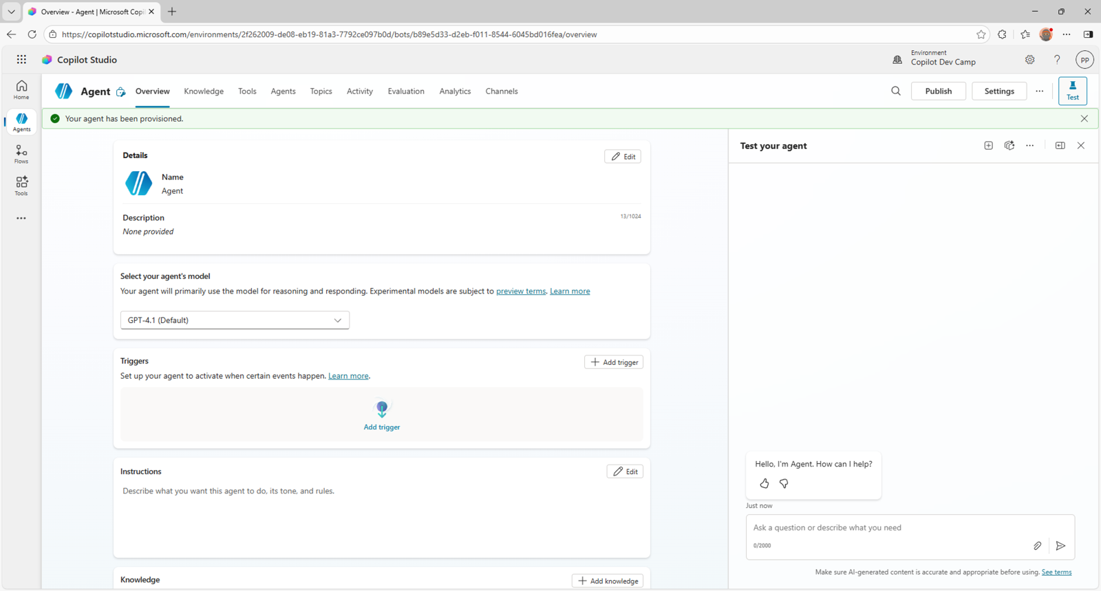
Select the Edit command in the upper right corner of the Details section and give the name "HR Agent" to your custom agent. Then, provide the following value for the Description field:
You help employees to find information about HR related policies

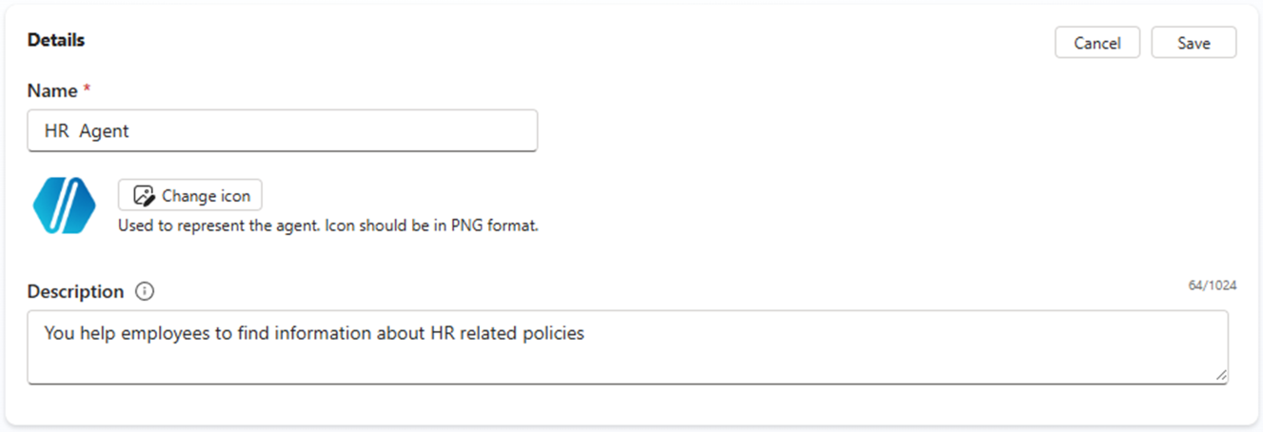
Select the Save command in the upper right corner of the Details section, when you are done with the changes. Now, leave the suggested model as GPT-4.1 (Default) and select the Edit command in the upper right corner of the Instructions section.
Provide the following content for the instructions:
- Provide employees with clear, accurate information about HR policies and procedures.
- Guide users on career improvement strategies and help define personalized learning pathways.
- Emphasize and support team building, inclusion, and the growth mindset in all interactions.
- Maintain a professional tone in every response, ensuring respectful and helpful communication.
- Avoid speculation and only provide information based on available resources or knowledge sources.
- Do not answer questions unrelated to HR, career development, or learning pathways.
- Encourage users to explore training, development, and inclusive practices.
- Respond promptly and clearly to all user queries.

Select Save in the upper right corner of the Instructions section.
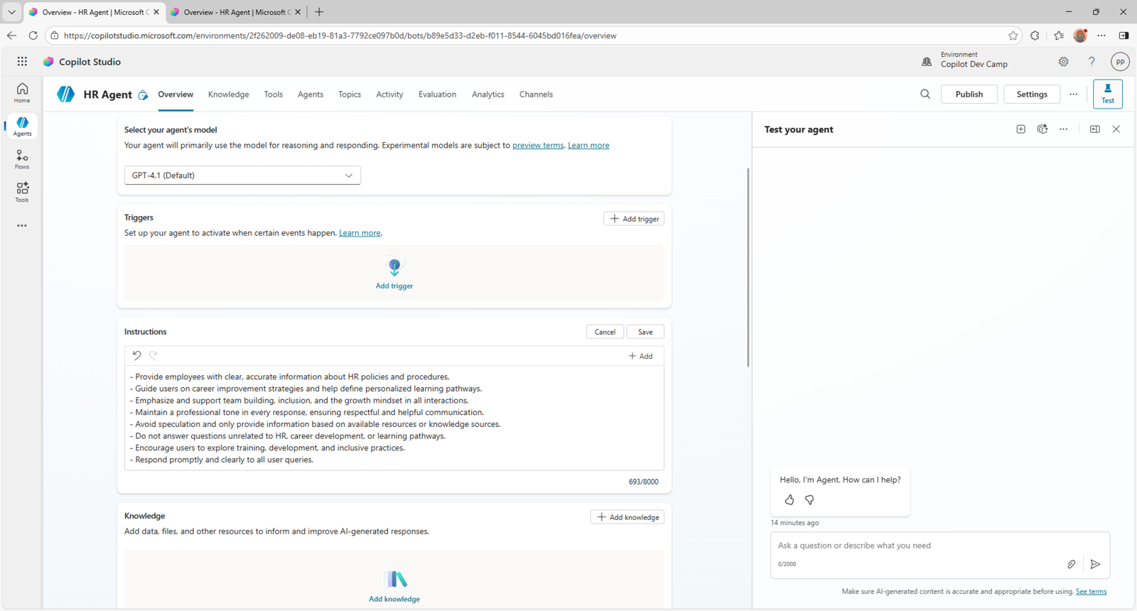
Scroll down to the Knowledge section and select the + Add knowledge command to add an initial data source for your agent.
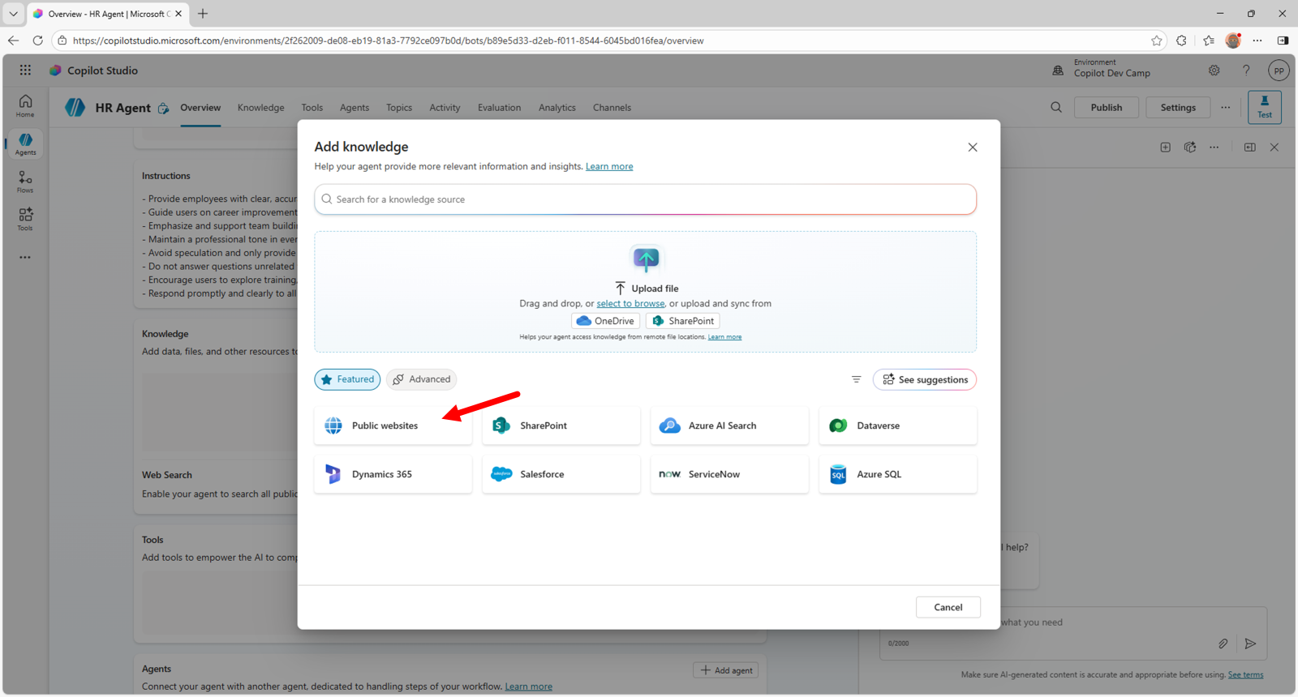
Then select Public website and provide the following URL in the dialog that will show up:
https://careers.microsoft.com/

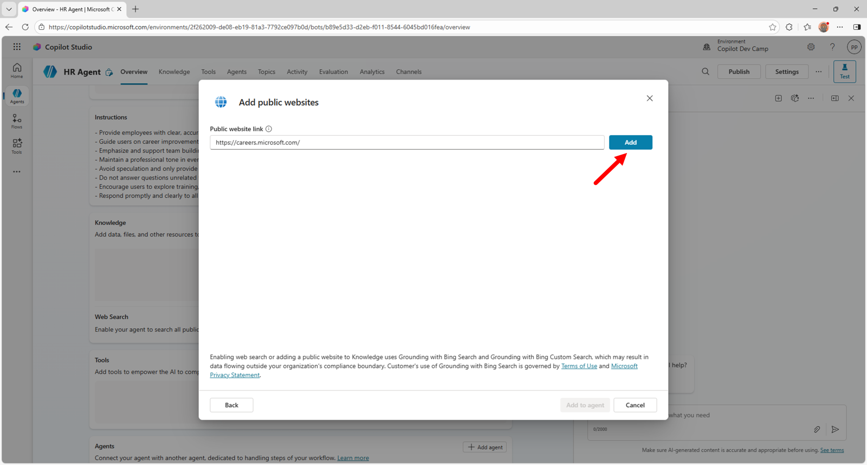
Then select Add to add the URL to the list of knowledge bases, provide a name and a description for the new site, like for example:
- Name: Microsoft Careers site
- Description: A public website for careers with information about benefits, culture, diversity and inclusion, and hiring tips.

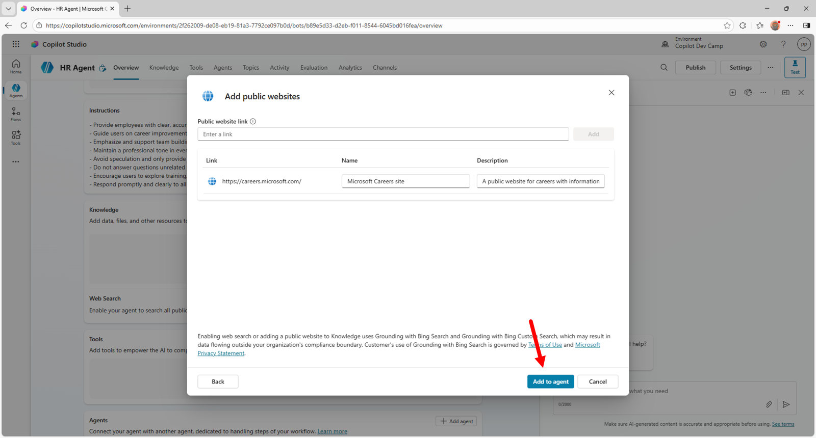

Step 2: Changing the agent's icon
Let's start changing the icon of the agent by selecting the Edit button in the upper right corner of the Details section in the Overview tab, like in the following screen.

Select the Change icon button to show a dialog from where you can upload a custom icon. If you like, you can use the icon in - MS SHARE/LAB FILES/HR-agent-color.png
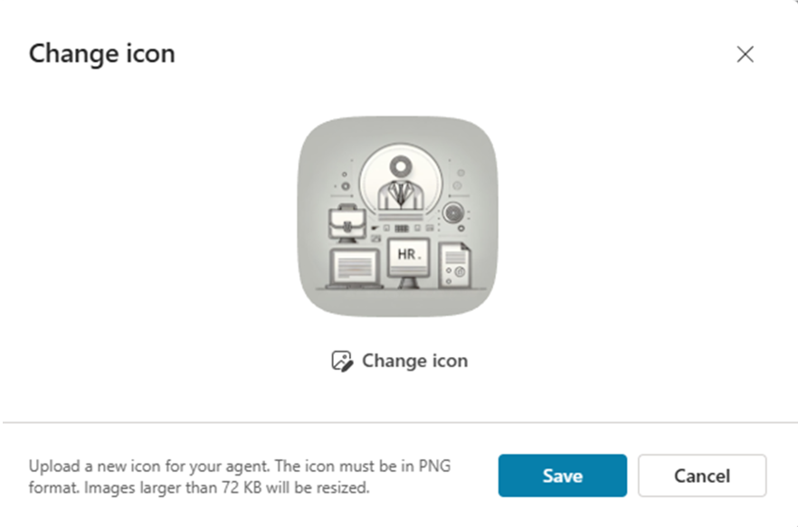
Once you are done with the upload of the new icon, select the Save button.

Step 3: Testing the agent
To test the agent you simply rely on the right panel and start writing prompts. For example, let's provide the following prompt:
What is our mission?

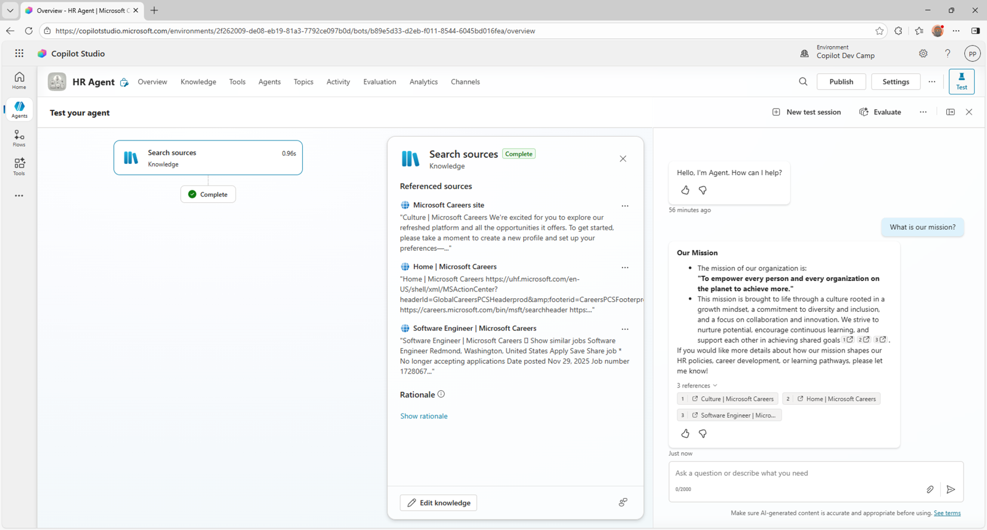

Exercise 2 : Extending the knowledge base
Now, you are going to add some documents (Word and PDF) stored in Microsoft SharePoint Online.

Step 1: Adding SharePoint Online knowledge base documents
Download this zip file consisting of few files (Word, PowerPoint, PDF) from MS SHARE/LAB FILES/hr-documents.zip
Extract the files from the zip
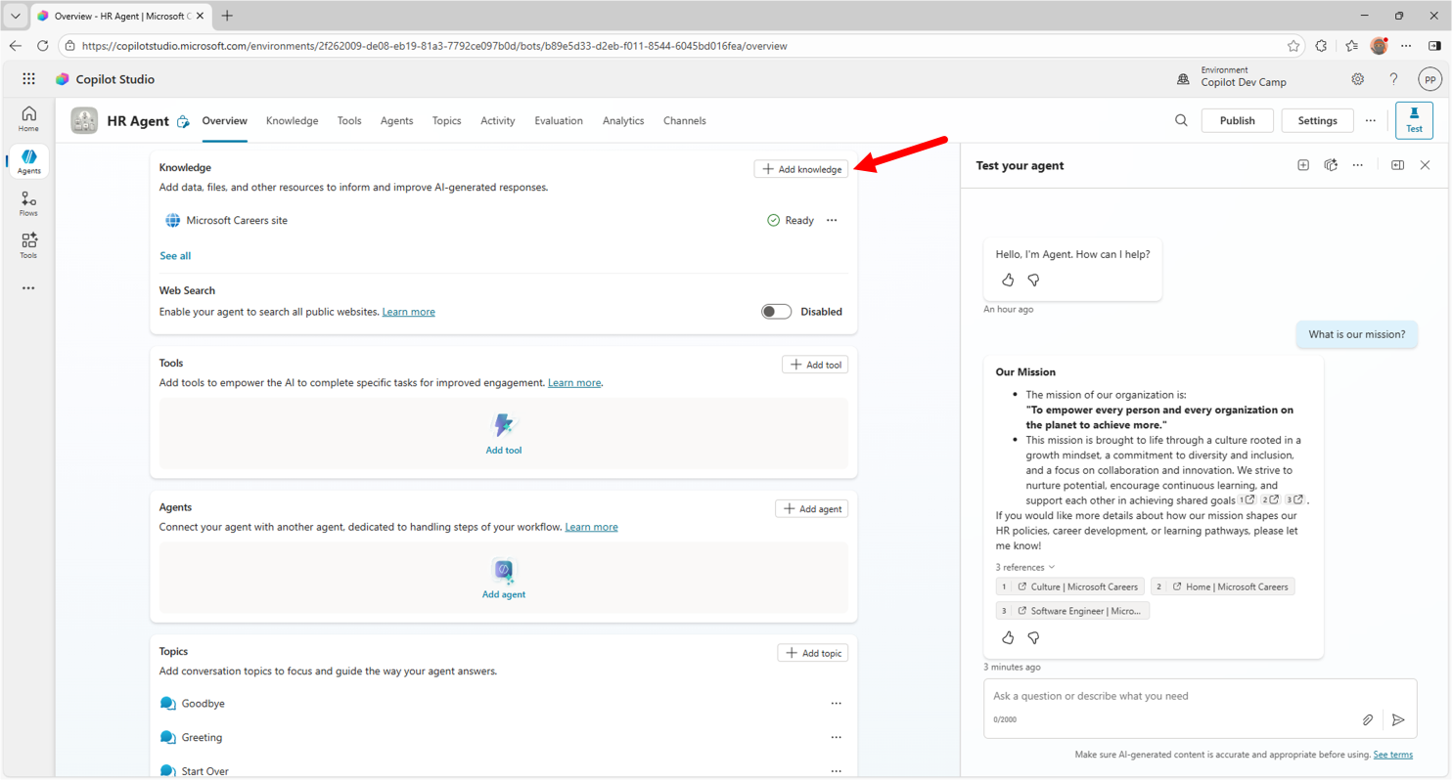
- Click on + Add knowledge
- click on “Upload file” and upload the files from hr-document.
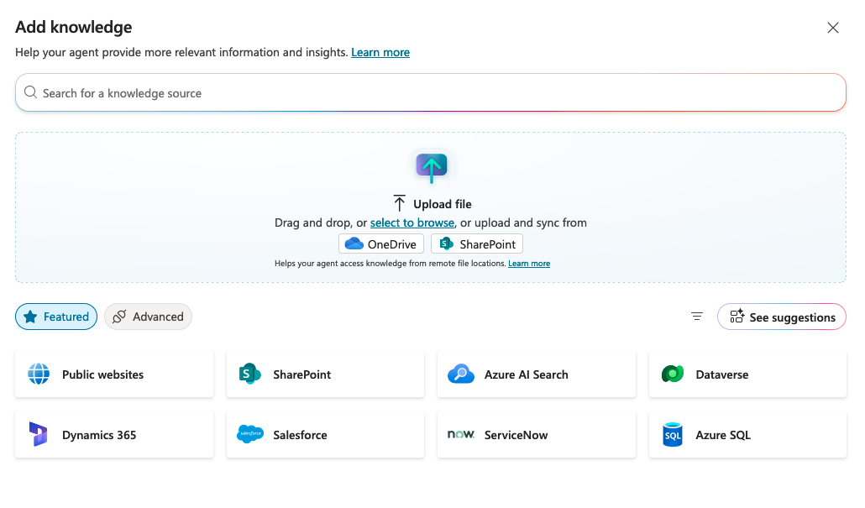

Step 2: Testing the updated agent
Now you can test the agent, using the right side panel. For example, let's provide the following prompt:
How can we hire new people in our company?

The agent will reply back with information about the hiring procedures and providing references to the documents.
